ANNEX 3
MUNICIPAL WASTE MANAGEMENT IN THE EUROPEAN UNION

Municipal waste management in the European Union

EU-15
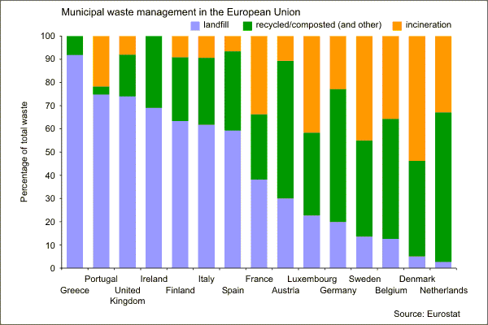
It is estimated that around 580 kilogrammes of municipal waste was produced on average by each person in the EU-15 countries in 2003.

Greece landfills over 90% of its municipal waste, and Portugal and the United Kingdom landfill around three quarters of their municipal waste. The Netherlands and Denmark dispose of almost no municipal waste to landfill, and Belgium, Sweden,Germany and Luxembourg all landfill less than a quarter of their municipal waste.

In Denmark, Sweden and Luxembourg incineration is the single main method of disposal and over half of Denmark’s municipal waste is treated in that way. The Netherlands and Austria recycle/compost around 60 per cent of their municipal waste and Belgium and Germany recycle/compost around half of theirs.

Note: Only broad comparisons can be made between countries because of differences in definitions of types of waste management. The recycling category includes some other recovery options (fuel manufacture, for example), which are negligible in most countries, but account for around 10 per cent of municipal waste in Germany, and 6 per cent in Spain.

EU-15 refers to the 15 members states of the European Union in the period prior to enlargement in 2004: Austria, Belgium, Denmark, Finland, France, Germany, Greece, Ireland, Italy, Luxembourg, the Netherlands, Portugal, Spain, Sweden and the United Kingdom.
Source: www.defra.gov.uk

